

Examinations 2026

Handbook for pupils, parents, and carers

Table of contents

Introduction 3
How do the exams work? 4
Examination regulations 7
Attendance during the examinations 8
Behaviour and conduct during an examination 10
Fire evacuation/lockdown 11
Unforeseen circumstances and special consideration 12
Results day 13
Appendix 1 - ‘Warning to candidates’ 14
Appendix 2 - ‘Mobile phone’ poster 15
Appendix 3 - Information for candidates –written examinations 16
Appendix 4 – Information for candidates - non-examination Assessments 20
Appendix 5 – Examples of malpractice 24
Appendix 6 – Privacy notice for candidates 26
Appendix 7 – Contingency day 29
Appendix 8 – Internal appeals procedure 30
Appendix 9 – External appeals procedure 32
Appendix 10 – Information for candidates – coursework assessments 36
Appendix 11 – JCQ – On your exam day 40
Appendix 12 – JCQ – Social media 41
Appendix 13 – Information for candidates – On-screen test 42
Appendix 14 – AI Use in Assessments: Protecting the Integrity of Qualifications 46
Statement of understanding 58

Introduction
This handbook will provide you with a guide to your exams this academic year. You should read this carefully and if you have any questions you should ask your form tutors, your achievement co-ordinator, the examinations officer, or a member of the senior leadership team.
This booklet provides you with the expectations and rules of the exams. It also repeats the key messages that you will have received in assemblies and our evening study-skills workshops.
A copy of this booklet will also be available on our school website and within the Student Portal.
Your key contacts
Waverley School will message parents/carers and pupils should there be any matters arising concerning the exams. All messages concerning the examinations schedule will be posted to the school website (www.waverley.bham.sch.uk).
If you have any questions about the contents of this booklet, or any concerns regarding the exams, you should contact a member of this team:
Examinations Officer | Mr C. Sharp
Achievement Co-ordinator | Mr O. Amin
Head of Centre | Mr H. Derry
Assistant-Principal (Assessment) | Mr G. Nandra

You can contact them by seeing them in-person in school, sending an e-mail via your school e-mail address, or e-mailing the enquiry@waverley.bham.sch.uk mailbox.
The school telephone number is 0121 566 6600
*** IMPORTANT NOTE ***

This booklet contains important information concerning the rules and conduct of examinations. It must be read by all candidates.

Ignorance of the rules for examinations will be an insufficient reason to excuse malpractice.

How do the exams work?
You will have received a copy of your personal examinations timetable. If you have not received this, you must speak to your form tutor or the Examinations Officer urgently.
The central examinations timetable for Waverley School has been published to the school website.
Your examinations timetable will show you:
- the exams for which you have been entered;
- your start time for the exams;
- the venue/location of your exams;
- your seat number for the exams;
- your candidate number;
- your unique learner number (ULN);
- your unique candidate identifier (UCI);
Examinations commence at 09:00 AM or 01:00 PM. You must be present at the exam venue, at least 30 minutes before the examination takes place:
Time to arrive at the venue | Exam start time
08:30 AM | 09:00 AM
12:30 PM | 01:00 PM
For most candidates, your exam will take place in the Sports Hall, however some of you will take your exams in different venues. You must check your examinations timetable carefully to make sure you are in the right place, at the right time.

Entering the examination venue
The following instructions explain the expectations for entering the examination venue.
- Line up outside of the venue in silence. Communication between candidates will delay the start of the examination.
- Ensure that you are not carrying an object or item on your person that is prohibited from the examination venue (see below).
- Wait to be called in to enter the venue. You may be called out by name or by seat number.
- Enter the examination venue in silence.
- Place your bags and coats at the front of the examination venue.
- Hand any prohibited items (see below) to an invigilator.
- Stand behind your allocated seat, facing the front of the examination venue. Do not turn around. Do not communicate with other candidates.
- Await instructions from the leading officer (usually the Examinations officer).
You will be provided with a briefing containing a summary of the rules and regulations. You will also be provided with any additional information required for the examination. You will be provided with an end time to the examination.
Leaving the examination venue
Candidates are required to remain within the examination venue until the end of the exam. There are exceptions to this rule and these are listed below.
The following instructions explain the expectations for leaving the examination venue.
- Await instructions before standing behind your chair.
- Collect your items from the front of the examination venue.
- Collect any prohibited items from the invigilators, should they be permitted in accordance with the school’s Behaviour Policy.
- Leave the examination venue in silence. Please remember that candidates may be considered to have committed malpractice if they communicate within the examination venue, even if the exam papers are not compromised.
- After exiting the examination venue, candidates are permitted to communicate.
- Move to the expected venue for your next school-based activity.

Additional rules
There are rules during the examination that you will need to be aware. These include:
- Rules during a fire or emergency evacuation;
- Rules during a lockdown event;
- Rules for attending an examination (including those who arrive late);
- Applying for special consideration.
There are also rules written by the Joint Council for Qualifications (JCQ) and the Department for Education (DFE) with which you will need to be familiar.
These rules have all been included below.

Examination regulations
A copy of the ‘Warning to candidates’ poster (Appendix 1) and ‘Mobile phone’ poster (Appendix 2) are issued jointly by all examination boards. These will be displayed outside of each examination room. They can be found on the website www.jcq.org.uk.
Information for candidates – both for written examinations and non-examination assessments are also included (Appendix 3 and Appendix 4 respectively).
All candidates must read these notices carefully.
Please note that the any breach of examination rules or regulations could lead to disqualification from all subjects.
Waverley School must report any breach of regulations to the awarding body.
You will be asked to sign a statement acknowledging the contents of these regulations. You will be asked to sign a statement agreeing to abide by the regulations.

Attendance during the examinations
Candidates are responsible for checking their own timetable and arriving at school on the correct day and time.
You must be in attendance at the venue of your exam 30 minutes prior to the exam commencing.
A briefing, reminding candidates of the exam room regulations, will be read out 5 minutes prior to the examination commencing. If you arrive late at the examination venue whilst this briefing is being read, you will be prevented from entering the venue. The briefing will be repeated for you prior to enter the examination venue.
If you arrive late, you will be permitted to sit the exam, and you will be allowed the full time for the examination.
If you arrive within one hour of the candidate of the awarding body’s published starting time for an examination, will be permitted to sit the examination.
If you arrive one hour later than the awarding body’s published starting time for the examination, will be considered to be ‘very late’ and permitted to sit the examination.
A candidate who arrives after the awarding body’s published starting time for an examination that lasts less than one hour, will be considered ‘very late’ and permitted to sit the examination.
Awarding bodies will be notified of candidates who are considered ‘very late’. The awarding body may not accept the script of candidates who are considered ‘very late’.
Candidates who do not attend an examination will be marked as ‘absent’. Unless the candidate is absent for a reason considered to be acceptable for special consideration by the examination bard, the centre may seek to recoup the cost of entry fees for the examination from the candidate.
Please note that misreading an examination timetable will not be accepted as a satisfactory explanation for an absence.

If you believe that you are unable to attend or will be late to your examination then you must:

- Telephone the school on 0121 566 6600 and ask to speak with your Achievement Co-ordinator or a member of the Senior Leadership Team. If you are unable to reach a member of staff via telephone, you must e-mail your Achievement Co-ordinator.
- Remain accessible by telephone to discuss the matter further.
- Complete the required documentation for the examination board to evidence the reason or your non-attendance. The Examinations Officer will advise you on the evidence required.

Behaviour and conduct during an examination
Inappropriate behaviour includes:
- A failure to adhere to the schools expectations under the Behaviour Policy (published via the school website);
- Breaching (deliberately or inadvertently) regulations imposed by the awarding body or Joint Council for Qualifications.
Examples of inappropriate behaviour is included as part of Appendix 5.
All instances of inappropriate behaviour will be considered candidate malpractice.

All instances of candidate malpractice will be reported to the awarding body.

The Head of Centre (and any member of staff who is delegated accordingly) may instruct a candidate to leave the examination venue.

Fire evacuation/lockdown
The school has a fire evacuation and lockdown procedure in place should an emergency arise.
Invigilators will provide candidates with clear instructions. You must follow these instructions.
If an evacuation is required, you will be evacuated to a designated location where you will remain in silence throughout the evacuation.
Candidates who communicate with one another during an evacuation will be considered to compromise the integrity of the examination and, as such, will be prevented from returning to the examination venue.
Actions taken in the event of an emergency evacuation of the examination room:
  - Candidates are instructed to stop writing.
  - The attendance register is collected.
  - The examination room is evacuated in line with the instructions given by the appropriate authority.
  - Candidates are instructed to leave all question papers and scripts in the examination room.
  - Candidates are advised to close their answer booklet(s).
  - Candidates are instructed to leave the room in silence.
  - Candidates are supervised as closely as possible while they are out of the examination room to make sure there is no discussion about the examination.
  - The time of the interruption is noted and how long it lasted.
  - Candidates are allowed the remainder of the working time set for the examination once it resumes.
  - If there are only a few candidates, the possibility is considered of taking the candidates (with question papers and scripts collected by the invigilator) to another place to finish the examination.
Upon return to the examination venue:
- When/if allowed to return to the examination room, invigilators allow candidates time to settle down, reminding them they are still under formal examination conditions and that they must not open their answer booklets until instructed to do so.
- Invigilators announce clearly to candidates when they may begin and how much time they have (the examination will formally restart at this point).
- Invigilators record the time the examination(s) restarted and amend the displayed finishing time(s) for all candidates to see.

Unforeseen circumstances and special consideration
If you experience difficulties before your examination (e.g. illness, injury, personal problems, etc.), please inform your ACO and/or the Vice-Principal at the earliest opportunity so that they can advise you.
Special consideration is given to a candidate who has temporarily experienced illness, injury or some other event outside of their control at the time of the assessment. It is applied when the issue or event has had, or is reasonably likely to have had, a material effect on a candidate’s ability to take an assessment or demonstrate his or her normal level of attainment in an assessment.
Special consideration can go some way to assist a candidate affected by a potentially wide range of difficulties, emotional or physical, which may influence performance in their examinations. It cannot remove the difficulty faced by the candidate. This means that there will be some situations where candidates should not be entered for an examination. This is because only minor adjustments can be made to the mark awarded. To make larger adjustments would jeopardize the standard of the examination.
All examinations measure what a candidate knows and can do. The overall grade(s) awarded must reflect the level of attainment demonstrated in the examination(s). The grades awarded do not necessarily reflect the candidate’s true level of ability if attainment has been considerably affected over a long period of time.
Where long term circumstances have prevented the candidate from reaching the competence standards, it may not be possible to make an adjustment.

Results day
Results day are currently scheduled for:
Year 13 | Thursday 13th August 2026
Year 11 | Thursday 20th August 2026

Further information, including the time for collecting results, will be published via the school website (www.waverley.bham.sch.uk).
If you do not come to school to collect your results, they will be posted to your home address.
Results will not be provided by telephone.
Post-results day services
All information regarding post-results day services will be shared with you prior to results day. There are strict deadlines for many services and therefore you should read this guidance carefully.
Further information concerning appeals of external assessments are included below as Appendix 10.

Appendix 1 - ‘Warning to candidates’
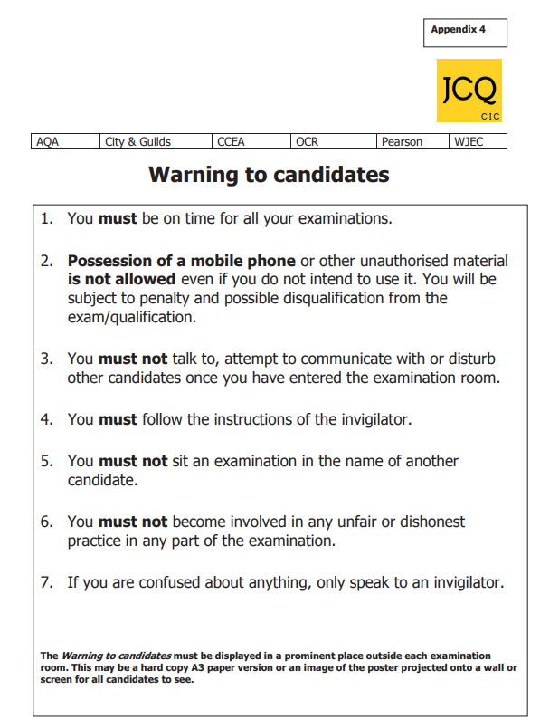

Appendix 2 - ‘Mobile phone’ poster



Appendix 3 - Information for candidates –written examinations

Please see additional documents under the ‘Exams’ section of the school website

Appendix 4 – Information for candidates - non-examination Assessments

Please see additional documents under the ‘Exams’ section of the school website

Appendix 5 – Examples of malpractice
This list of examples of candidate malpractice is not intended to be exhaustive. For further reference as to what constitutes candidate malpractice, please refer to the policy guidance above and the guidance published by the Joint Council for Qualifications (JCQ).
INTRODUCTION OF UNAUTHORISED MATERIAL INTO THE EXAMINATION ROOM, FOR EXAMPLE:
- Own blank paper used for rough work used for final answers
- Calculators, dictionaries (when prohibited) not used or attempted to use
- Bringing into the examination room notes in the wrong format or prohibited annotations
- notes/annotations go beyond what is permitted but do not give an advantage; notes irrelevant to subject notes/annotations are relevant and give an unfair advantage notes/annotations introduced in a deliberate attempt to gain an advantage
- Study guides and personal organisers
- content irrelevant to subject
- content relevant to subject
- content relevant to subject and evidence of use
- Mobile phone or similar electronic devices (including iPod, PM3/4 player, memory sticks, Smartphone, Smartwatch) not in the candidate’s possession but make a noise in the examination room in the candidate’s possession but no evidence of being used by the candidate in the candidate’s possession and evidence of being used by the candidate

BREACHES OF EXAMINATION CONDITIONS
- A breach of the instructions or advice of an invigilator, supervisor, or the awarding body in relation to the examination rules and regulations
- minor non-compliance: e.g. sitting in a non-designated seat; continuing to write for a short period after being told to stop major non-compliance: e.g. refusing to move to a designated seat; significant amount of writing after being told to stop related non-compliance
- Failing to abide by the conditions of supervision designed to maintain the security and integrity of the examinations
- leaving examination early (no loss of integrity); removing script from the examination room, but evidence of the integrity was maintained
- removing script from examination room but with no proof that the script is safe;
- opening an exam script before the commencement of an exam;
- taking home materials
- deliberately breaking a timetable clash supervision arrangement;
- removing script from the examination room and with proof that the script has been tampered with;
- leaving examination room early so integrity is impaired
- Disruptive behaviour in the examination room or assessment session (including use of offensive language)
- minor disruption lasting a short time; calling out, causing noise, turning around repeated or prolonged disruption; unacceptably rude remarks; being removed from the examination room; taking another’s possessions
- warnings ignored;
- provocative or aggravated behaviour;
- repeated or loud offensive comments;
- physical assault on staff or property

EXCHANGE, OBTAINING, RECEIVING, OR PASSING ON INFORMATION WHICH COULD BE EXAMINATION RELATED (OR THE ATTEMPT TO):
- Verbal isolated incidents of talking before the start of the examination or after papers have been collected talking during the examination about matters not related to the exam;
- accepting examination related information talking about examination related matters during the exam;
- whispering answers to questions
- Communication passing/receiving written communications which clearly have no bearing on the assessment
- accepting assessment related information
- passing assessment related information to other candidates; helping one another; swapping scripts

OFFENCES RELATING TO THE CONTENT OF CANDIDATES’ WORK
- The inclusion of inappropriate, offensive or obscene material in scripts, controlled assessments, coursework, non- examination assessments or portfolios
- isolated words or drawings, mildly offensive, inappropriate approaches or responses
- frequent mild obscenities or drawings;
- isolated strong obscenity;
- isolated mild obscenities or mildly offensive comments aimed at the examiner or member of staff
- offensive comments or obscenities aimed at a member of staff, examiner or religious group; homophobic, transphobic, racist or sexist remarks or lewd drawing

Appendix 6 – Privacy notice for candidates

Please see additional documents under the ‘Exams’ section of the school website

Appendix 7 – Contingency day

The awarding bodies have collectively agreed a contingency day for several years now which is always scheduled at the end of the GCSE, GCE AS and A-level exam timetables.

The contingency day is in the event of national or significant local disruption to exams in the United Kingdom, being part of the awarding bodies’ standard contingency planning for exams.

Schools and colleges should ensure candidates and parents are aware of the contingency arrangements on these three days. Candidates should be encouraged to remain available until Friday 26 June 2026 should examinations need to be rescheduled.

Appendix 8 – Internal appeals procedure
Waverley School is committed to ensuring that whenever its staff mark candidates’ work, this is done fairly, consistently and in accordance with the awarding body’s specification and subject-specific associated documents.
Candidates’ work will be marked by staff who have appropriate knowledge, understanding and skill, and who have been trained in this activity. Waverley School is committed to ensuring that work produced by candidates is authenticated in line with the requirements of the awarding body. Where a number of subject teachers are involved in marking candidates’ work, internal moderation and standardisation will ensure consistency of marking.
The following procedure explains how candidates can appeal an internally assessed decisions (coursework, controlled assessments, non-examined assessments) :
  - Candidates are informed of their centre assessed marks so that they may request a review of the centre’s marking before marks are submitted to the awarding body
  - Candidates will need to explain on what grounds they wish to request a review of an internally assessed mark as a review will only focus on the quality of their work in meeting the published assessment criteria
  - Candidates may request copies of materials (for example, as a minimum, a copy their marked assessment material (work) and the mark scheme or assessment criteria plus additional materials which may vary from subject to subject) to assist them in considering whether to request a review of the centre’s marking of the assessment
  - The materials will be made available to the candidate (for some marked assessment materials, such as art work and recordings, inform the candidate that these will be shared under supervised conditions) within the period of time as specified (see Deadlines below)
  - Candidates will have sufficient time in order to allow them to review copies of materials and reach a decision. If candidates wish to request a review, they will need to explain what they believe the issue to be
  - There will be a clear deadline for candidates to submit a request for a review of the centre’s marking and confirm understanding that requests must be made in writing and will not be accepted after this deadline.
  - Candidates allow the centre sufficient time for the review to be carried out, to make any necessary changes to marks and to inform the candidate of the outcome, all before the awarding body’s deadline
  - The review of marking is carried out by an assessor who has appropriate competence, has had no previous involvement in the assessment of that candidate and has no personal interest in the review
  - The candidates will be informed in writing of the outcome of the review of the centre’s marking
  - The outcome of the review of the centre’s marking is made known to the head of centre who will have the final decision if there is any disagreement on the mark to be submitted to the awarding body
  - A written record of the review is kept and made available to the awarding body upon request
  - The awarding body is informed if the centre does not accept the outcome of a review

Appendix 9 – External appeals procedure
The following procedure explains how candidates can appeal an externally assessed decision:
- The JCQ post-results services currently available are detailed below.
  - Reviews of Results (RoRs):
    - Service 1 (Clerical re-check) - This is the only service that can be requested for objective tests (multiple choice tests)
    - Service 2 (Review of marking)
    - Priority Service 2 (Review of marking) - This service is only available for externally assessed components of GCE A-level specifications (an individual awarding body may also offer this priority service for other qualifications)
    - Service 3 (Review of moderation) - This service is not available to an individual candidate
  - Access to Scripts (ATS):
    - Copies of scripts to support reviews of marking
    - Copies of scripts to support teaching and learning

- Where a concern is expressed that a particular result may not be accurate, Waverley School will:
  - Look at the marks awarded for each component part of the qualification alongside any mark schemes, relevant result reports, grade boundary information etc., when made available by the awarding body, to determine if the concern may be justified
  - Where a place a university or college is at risk, consider supporting a request for a Priority Service 2 review of marking
  - In all other instances:
    - Consider accessing the script by:
      - (where the service is made available by the awarding body) requesting a priority copy of the candidate’s script to support a review of marking by the awarding body deadline OR
      - (where the option is made available by the awarding body) viewing the candidate’s marked script online to consider if requesting a review of marking is appropriate
      - Collect written consent/permission from the candidate to access the script
  - On access to the script, consider if it is felt that the agreed mark scheme has been applied correctly in the original marking and if the centre considers there are any errors in the marking
  - Support a request for the appropriate Review of Results service (clerical re-check or review of marking) if any error is identified
  - Collect written consent from the candidate to request the Review of Results service before the request is submitted
  - Where relevant, advise an affected candidate to inform any third party (such as a university or college) that a review of marking has been submitted to an awarding body
- For moderated components that contributed to the final grade Waverley School (WS), Waverley Studio College (WSC) will:
  - Confirm that a review of moderation cannot be undertaken on the work of an individual candidate or the work of candidates not in the original sample submitted for moderation
  - Consult the moderator’s report/feedback to identify any issues raised
  - Determine if the centre’s internally assessed marks have been accepted without change by the awarding body – if this is the case, a Review of Results service 3 (Review of moderation) will not be available
  - Determine if there are any grounds to submit a request for a review of moderation for all candidates in the original sample

- Waverley School will:
  - Acquire written candidate consent (accepting informed consent via candidate email) in all cases before a request for a Review of Results service 1 or 2 (including priority service 2) is submitted to the awarding body
  - Acquire informed candidate consent to confirm the candidate understands that the final subject grade and/or mark awarded following a clerical recheck or a review of marking, and any subsequent appeal, may be lower than, higher than, or the same as the result which was originally awarded
  - Only collect candidate consent after the publication of results
- Centre actions in the event of a disagreement (dispute)
- Where a candidate disagrees with a centre decision not to support a clerical re-check, a review of marking or a review of moderation, Waverley School (WS) will:
  - For a review of marking (Review of Results priority service 2), advise the candidate a review may be requested by providing informed written consent (and the required fee) for this service to the centre by the deadline set by the centre
  - For a review of marking (Review of Results service 1 or 2), first advise the candidate to access a copy of their script to support a review of marking by providing written permission (and any required fee) for the centre to access the script from the awarding body
  - After accessing the script to consider the marking, inform the candidate that if a request for a review of marking (Review of Results service 1 or 2) is required, this must be submitted by the deadline set by the centre by providing informed written consent (and the required fee) for the centre to request the service from the awarding body
  - Inform the candidate that a review of moderation (Review of Results service 3) cannot be requested for the work of an individual candidate or the work of a candidate not in the original sample
- If the candidate (or his/her parent/carer) believes there are grounds to appeal against the centre’s decision not to support a review of results, an internal appeal can be submitted to the centre.
- The appellant will be informed of the outcome of the appeal by the Head of Centre.

- Appeals

- Following a Review of Results outcome, an external appeals process is available if the head of centre at Waverley School (WS), remains dissatisfied with the outcome and believes there are grounds for appeal.
- The JCQ publications Post-Results Services and JCQ Appeals Booklet (A guide to the awarding bodies’ appeals processes) will be consulted to determine the acceptable grounds for a preliminary appeal.
- Where the head of centre is satisfied after receiving the Review of Results outcome, but the candidate (or parent/carer) believes there are grounds for a preliminary appeal to the awarding body, an internal appeal may be made directly to the centre. Candidates or parents/carers are not permitted to make direct representations to an awarding body. Following this, the head of centre’s decision as to whether to proceed with a preliminary appeal will be based upon the acceptable grounds as detailed in the JCQ Appeals Booklet.
- To submit an internal appeal:
  - An internal appeals form should be completed and submitted to the centre within the time specified by the centre from the notification of the outcome of the review of the result
  - Subject to the head of centre’s decision, the preliminary appeal will be processed and submitted to the awarding body within the required 30 calendar days of receiving the outcome of the Review of Results process
  - Awarding body fees which may be charged for the preliminary appeal must be paid to the centre by the appellant before the preliminary appeal is submitted to the awarding body (fee schedules are available from the exams officer)
  - If the appeal is upheld by the awarding body, this fee will be refunded by the awarding body and repaid to the appellant by the centre.

Further guidance to inform and implement appeals procedures
JCQ publications
General Regulations for Approved Centres
https://www.jcq.org.uk/exams-office/general-regulations
Post-Results Services
https://www.jcq.org.uk/exams-office/post-results-services
JCQ Appeals Booklet
https://www.jcq.org.uk/exams-office/appeals
Notice to Centres - Reviews of marking (centre assessed marks)
https://www.jcq.org.uk/exams-office/coursework
https://www.jcq.org.uk/exams-office/non-examination-assessments
Notice to Centres – informing candidates of their centre assessed marks
https://www.jcq.org.uk/exams-office/non-examination-assessments
Ofqual publications
GCSE (9 to 1) qualification-level conditions and requirements
https://www.gov.uk/government/publications/gcse-9-to-1-qualification-level- conditions
GCE qualification-level conditions and requirements
https://www.gov.uk/government/publications/gce-qualification-level-conditions- and-requirements

Appendix 10 – Information for candidates – coursework assessments

Please see additional documents under the ‘Exams’ section of the school website

Appendix 11 – JCQ – On your exam day
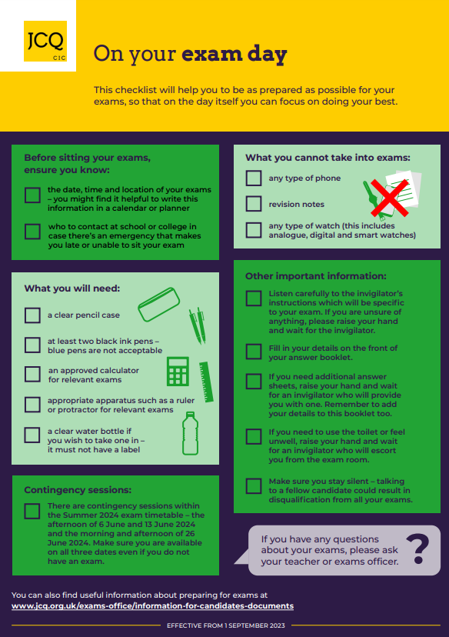

Appendix 12 – JCQ – Social media

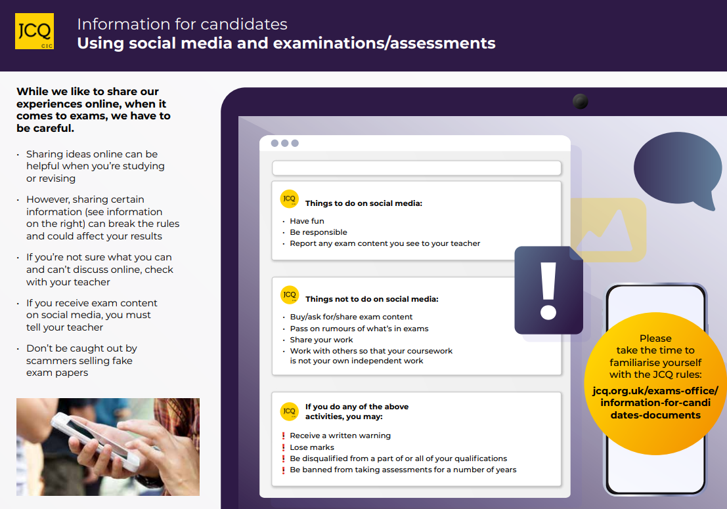

Appendix 13 – Information for candidates – On-screen test
Please see additional documents under the ‘Exams’ section of the school website

Appendix 14 – AI Use in Assessments: Protecting the Integrity of Qualifications

Please see additional documents under the ‘Exams’ section of the school website

Statement of understanding
By signing this statement, I acknowledge that I have read and understood the contents of the following documents:
- JCQ Warning for candidates (included as Appendix 1)
- JCQ Mobile phone warning (included as Appendix 2)
- JCQ Information for candidates – written exams (included as Appendix 3)
- Examples of malpractice (included as Appendix 5)
- JCQ AI Use in Assessments ((included as Appendix 14)
I acknowledge that I have received a copy of the Examinations Handbook 2026 and will familiarise myself with the entire contents.
I understand and acknowledge that I must contact the school promptly should I be unable to attend an examination or will be arriving late for an examination.
I acknowledge that I have received a copy of my personal examination timetable.
I understand that it is my responsibility to retain a copy of my personal examination timetable.
I understand that misreading my personal examination timetable is not an acceptable reason for missing an examination start time.
I understand the behaviour expectations for my conduct during the examinations.
I understand that malpractice, including failure to follow the regulations of the assessment, may result in disqualification from all or some of my entered subjects.

Candidate declaration
First name: | Surname:
Signature: | Date:
Form-tutor: | Signature:

